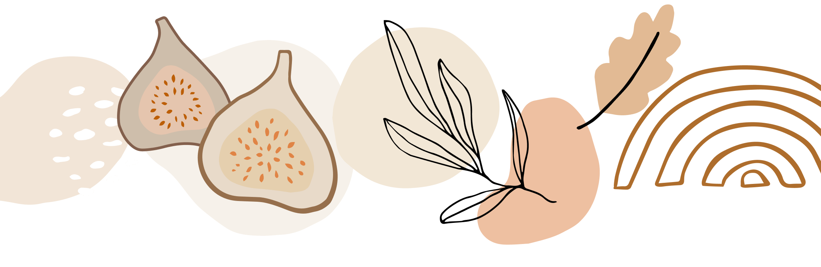

### **1. Wind Energy Timeline**

* **2000 BC**: Earliest windmills used in Persia for grinding grain and pumping water.
* **1887**: First known wind turbine for generating electricity built by Professor James Blyth in Scotland.
* **1970s**: Wind energy resurgence during oil crisis; Denmark leads modern wind turbine design.
* **1980:** First wind farm appears in New Hampishire
* **1991**: World's first offshore wind farm opens in Denmark.
* **2000s**: Massive growth in onshore wind farms globally; offshore wind grows in Europe.
* **2010**: Wind energy becomes mainstream in the US, China, and Europe.
* **2020**: Wind power generates 8% of global electricity, with advancements in floating turbines.
* **2024**: Significant progress in blade designs for efficiency and power output, especially offshore.

### **2. Solar Energy Timeline**

* **7th Century BC**: Earliest use of magnifying glasses to concentrate sunlight to make fire.
* **1839**: Photovoltaic effect discovered by Alexandre Edmond Becquerel.
* **1954**: Bell Labs creates the first practical silicon solar cell, sparking solar electricity.
* **1970s**: Oil crisis spurs solar research; solar panels used in space programs.
* **1990s**: Solar energy costs begin dropping significantly, solar rooftops gain popularity.
* **2000s**: Solar photovoltaic (PV) capacity grows rapidly worldwide, especially in Germany and Japan.
* **2010**: Solar power becomes increasingly cost-competitive with fossil fuels.
* **2020**: Solar power accounts for nearly 3% of global electricity production.
* **2024**: Advances in solar panel efficiency and storage, with solar grids becoming a significant power source in many countries.

### **3. Hydropower Timeline**

* **~200 BC**: Waterwheels used by the Greeks and Romans for milling and irrigation.
* **1880**: First hydroelectric power plant opens in Northumberland, England.
* **1930s**: Large-scale hydroelectric projects like the Hoover Dam begin.
* **1950s**: Hydropower becomes the dominant source of renewable electricity worldwide.
* **1990s**: Modern turbines improve efficiency and reduce environmental impacts.
* **2010**: Focus shifts to small-scale hydropower systems to minimize environmental impact.
* **2020**: Hydropower produces over 16% of the world’s electricity, leading all renewables.
* **2024**: Growth in pumped storage hydropower and efforts to balance ecosystem health with energy production.

### **4. Geothermal Energy Timeline**

* **10,000 BC**: Native Americans and other early civilizations use hot springs for cooking and bathing.
* **1904**: First geothermal power plant built in Larderello, Italy.
* **1960**: First commercial geothermal power plant in the US at The Geysers, California.
* **1970s**: Oil crisis triggers geothermal research; new systems deployed in Iceland and the US.
* **1990s**: Development of enhanced geothermal systems (EGS) to boost output from geothermal reservoirs.
* **2010**: Geothermal power expands beyond volcanic regions; interest in geothermal heating and cooling grows.
* **2020**: Geothermal energy provides about 0.3% of global electricity.
* **2024**: Advances in deep geothermal drilling and use in urban heating systems.

### **5. Biomass Energy Timeline**

* **10,000 BC**: Humans begin using wood and organic matter for fuel.
* **1850s**: Wood remains the primary source of energy in the US before coal overtakes it.
* **1970s**: Oil crises spur research into biofuels, including ethanol and biodiesel.
* **1990s**: Biomass energy, including agricultural waste and algae, starts to be seen as a renewable alternative.
* **2000s**: Increased use of bioenergy for electricity generation and liquid biofuels in the transport sector.
* **2010**: Biomass energy makes up a significant portion of renewable energy globally.
* **2020**: Focus on sustainable biomass sourcing, with increased production of second-generation biofuels. `
* **2024**: Algae-based biofuels and waste-to-energy technologies advance, helping mitigate carbon footprints.